**Quantum deep reinforcement learning for clinical decision support in oncology.**

**Lubna Ibrahim & Sama Ibrahim**

***April* *2023***

Subtle differences in a patient’s genetics and physiology may alter radiotherapy (RT) treatment responses, motivating the need for a more personalised treatment plan.

Our framework considers patients’ specific information including biological, physical, genetic, clinical, and dosimetric factors. Recognizing that physicians must make decisions

amidst uncertainty in RT treatment outcomes.

We paired quantum decision states with a model-based deep q-learning algorithm to optimise the clinical decision-making process in RT.

Two metrics were considered to evaluate our framework:

(1) similarity score, defined as the root mean square error between retrospective clinical decisions and the AI recommendations.

(2) self-evaluation scheme that compares retrospective clinical decisions and AI recommendations based on the improvement in the observed clinical outcomes. Our analysis shows that our framework, which takes into consideration individual patient dose response in its decision-making, can potentially improve clinical RT decision-making by at least about 10% compared to unaided clinical practice. Further validation of our novel quantitative

Notes:

DRL stands for "Deep Reinforcement Learning," which is a type of machine learning that involves training an agent to make decisions in an environment based on rewards and punishments.

qDRL, on the other hand, stands for "Quantum Deep Reinforcement Learning," which is a type of DRL that leverages quantum computing to perform the computations required for training the agent.

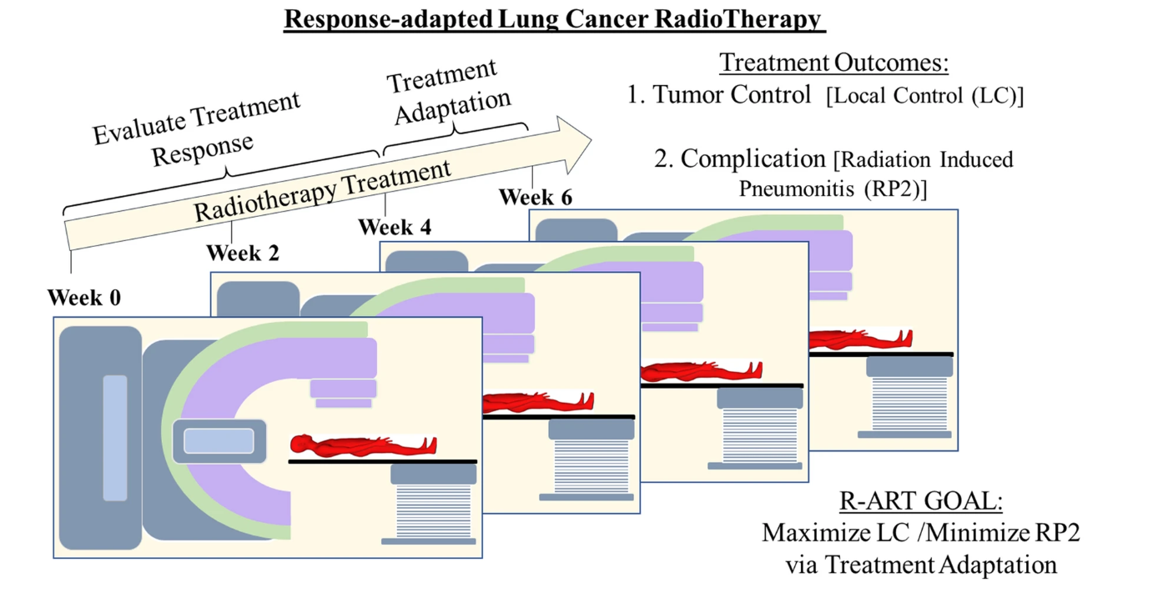

Figure 1.  Schematics of response-adapted lung cancer radiotherapy. Response-adapted radiotherapy evaluates treatment response in the first two-thirds (week 1 to week 4) of the treatment period and then makes necessary adaptation in the last third (week 5 to week 6), with the goal of optimising the treatment plan. For the case of lung cancer, optimization translates into maximising tumour (local) control (LC) and minimising radiation-induced pneumonitis of grade 2 or higher (RP2).

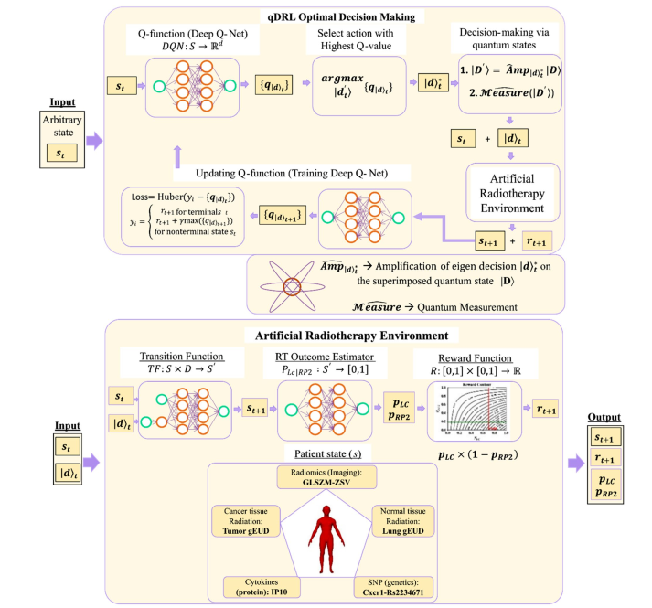

Figure 2.  Quantum deep reinforcement learning algorithm for optimal decision making in knowledge-based adaptive radiotherapy. Schematic of a quantum deep reinforcement learning (qDRL) algorithm for optimal decision making in knowledge-based adaptive radiotherapy. qDRL employs deep q-net as a decision optimization algorithm and employs quantum state as the decision. Here, qDRL is a model-based algorithm that utilizes an artificial radiotherapy environment (ARTE) as the RL model. The qDRL artificially intelligent (AI) agent.

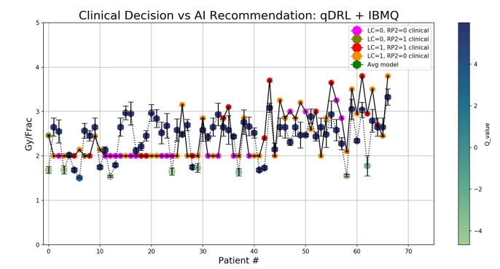

Figure 3.  Clinical decision support system dose adaptation recommendation. Comparison between retrospective clinical decision and AI recommendations obtained from the quantum deep reinforcement learning (qDRL) model trained in the IBMQ quantum processor.

**Methods:**

1)-Quantum deep reinforcement learning.

2)-Quantum amplification method and controller circuit.

**Quantum deep reinforcement learning (QDRL):**- is a field of research that combines two areas of study: deep reinforcement learning and quantum computing. In traditional deep reinforcement learning, an agent learns to perform a task by receiving feedback in the form of rewards or penalties. In QDRL, the agent is trained using quantum algorithms and hardware to learn and make decisions.

One of the main advantages of QDRL is the potential to solve problems that are beyond the capabilities of classical computers. Quantum computers can perform calculations exponentially faster than classical computers, which makes them well-suited for complex optimization problems. QDRL can be used to solve problems in various domains, such as finance, logistics, and natural language processing.

However, there are several challenges in implementing QDRL. One of the main challenges is the lack of suitable quantum hardware and software. Another challenge is the need to develop new algorithms and techniques that are tailored to the unique features of quantum computing.

Despite these challenges, QDRL has the potential to revolutionize the field of reinforcement learning and enable the development of more advanced and intelligent systems.

**Quantum amplification:** is a method used in quantum computing to amplify the signal of a quantum state. In classical computing, signals can be amplified using electronic circuits, but in quantum computing, amplification requires a different approach due to the nature of quantum states.

One approach to quantum amplification is the use of a quantum controller circuit, which is a circuit that can be used to control the state of a quantum system. The quantum controller circuit can be used to amplify the signal of a quantum state in a process called quantum state amplification.

One example of a quantum controller circuit is the quantum feedback control circuit, which uses feedback to control the state of a quantum system. The circuit consists of a quantum feedback loop that measures the state of the system and applies a feedback control signal to adjust the state of the system.

Another example of a quantum controller circuit is the quantum error correction circuit, which is used to correct errors in quantum computations. The circuit consists of a set of qubits that are used to encode information and detect errors, along with a set of operations that can be used to correct the errors.

In summary, quantum amplification is a method used in quantum computing to amplify the signal of a quantum state, and a quantum controller circuit can be used to control the state of a quantum system and amplify the signal of a quantum state. These circuits are important tools for building more advanced and robust quantum computing systems.

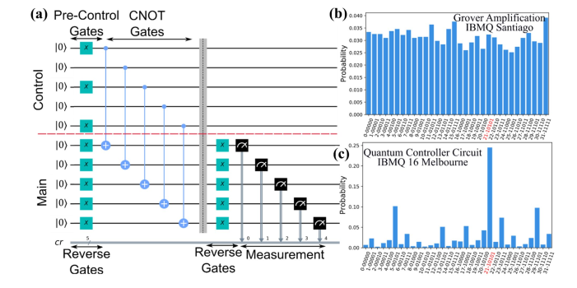

Figure 4.  Quantum controller circuit for a 5 qubit (32 bit) system. (a) Quantum controller circuit for the selection of the state |10101�. The probability distribution corresponding to (b) failed Grover’s amplification procedure for one iteration run in the 5-qubit IBMQ Santiago quantum processor and (c) successful quantum controller selection run in the 15-qubit IBMQ Melbourne quantum processor.

**References:**

1)

<https://www.researchgate.net/publication/356842001_Quantum_deep_reinforcement_learning_for_clinical_decision_support_in_oncology_application_to_adaptive_radiotherapy>

2)

<https://www.nature.com/articles/s41598-021-02910-y>